1.In which OSI layer the Wi-Fi standard/protocol fits.
Wi-Fi, which is based on the IEEE 802.11 standard, mainly works in the Data Link Layer (Layer 2) of the OSI model.
Wi-Fi helps in managing things like sending data in the form of frames, using MAC addresses to identify devices, and controlling how multiple devices share the wireless medium without causing too many collisions.
2.Can you share the Wi-Fi devices that you are using day to day life, share that device's wireless capability/properties after connecting to network. Match your device to corresponding Wi-Fi Generations based on properties
In my day-to-day life, I use several Wi-Fi-enabled devices such as a smartphone, laptop, and smart TV. These devices connect to the internet using Wi-Fi based on the IEEE 802.11 standard.
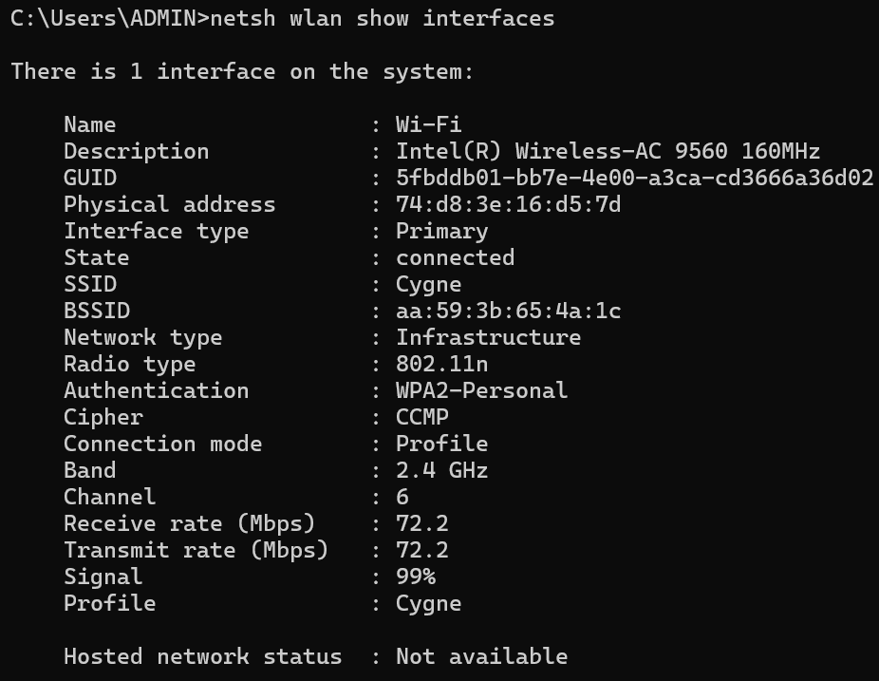

Observed Wi-Fi Properties from My Device
- Device Name: Wi-Fi (Laptop)
- Adapter: Intel(R) Wireless-AC 9560
- Connection Status: Connected
- Network Name (SSID): Cygne
- Network Type: Infrastructure
Wireless Capability Details
- Radio Type: 802.11n
- Frequency Band: 2.4 GHz
- Channel: 6
- Receive Speed: 72.2 Mbps
- Transmit Speed: 72.2 Mbps
- Signal Strength: 99%
Security Details
- Authentication: WPA2-Personal
- Encryption: CCMP
Wi-Fi Generation Mapping
The radio type shown is 802.11n, which corresponds to:
802.11n (Wi-Fi 4)
From the above data, even though my laptop supports advanced Wi-Fi (AC), it is currently connected using 802.11n (Wi-Fi 4) on the 2.4 GHz band. This results in a moderate speed of around 72 Mbps. The signal strength is very strong (99%), indicating a stable connection. Thus, based on the observed properties, my device is currently operating on Wi-Fi 4 (802.11n). The performance is stable, but higher speeds can be achieved if connected to a 5 GHz network using newer standards like Wi-Fi 5 or Wi-Fi 6.
3.what is BSS and ESS?
In wireless networking based on the IEEE 802.11 standard, networks are organized into two main types called BSS and ESS.

1. BSS (Basic Service Set)
A Basic Service Set (BSS) is the smallest unit of a Wi-Fi network.
In simple terms, it means,One Wi-Fi router (access point) connected to multiple devices like mobile phones, laptops, etc.
- All devices communicate through a single access point
- It covers a limited area (like a room or small house)
- Each BSS has a unique identifier called BSSID (MAC address of the router)
Eg.Your home Wi-Fi where all devices connect to one router is a BSS.

2. ESS (Extended Service Set)
An Extended Service Set (ESS) is formed when multiple BSS networks are connected together.
In simple terms,that means,Many routers (access points) are connected to form one large Wi-Fi network
- Covers a larger area (like colleges, offices, malls)
- All access points share the same network name (SSID)
- Devices can move from one area to another without disconnecting (roaming)
Eg.Wi-Fi in a college campus where multiple routers provide continuous connectivity is an ESS.
4. what are the basic functionalities of Wi-Fi Accesspoint
A Wi-Fi Access Point (AP), based on the IEEE 802.11 standard, is a device that allows wireless devices like mobiles and laptops to connect to a wired network or the internet.
The main functions of a Wi-Fi Access Point are:

1. Provides Wireless Connectivity
The access point allows devices to connect wirelessly instead of using cables, making internet access easy and flexible.

2. Acts as a Bridge
It works as a bridge between wireless devices and the wired network (like a router or internet connection).

3. Manages Device Connections
The AP controls how multiple devices connect and communicate, ensuring smooth data transmission.

4. Uses SSID (Network Name)
It broadcasts a network name (SSID) so that users can find and connect to the Wi-Fi network.

5. Ensures Security
The access point provides security features like passwords and encryption (WPA2/WPA3) to protect the network from unauthorized access.

6. Controls Data Traffic
It manages how data is sent and received between devices, helping to reduce collisions and improve performance.

7. Supports Multiple Devices
An AP can connect many devices at the same time, such as phones, laptops, and smart TVs.

8. Provides Coverage Area

It creates a wireless coverage area where devices can connect. Multiple APs can be used to extend coverage.

5.Difference between Bridge mode and Repeater mode
In Wi-Fi networks based on the IEEE 802.11:
- Bridge Mode is used to connect two different networks together. It acts like a link between two routers or LANs and does not increase Wi-Fi range.
- Repeater Mode is used to extend the existing Wi-Fi signal. It receives the signal and rebroadcasts it to cover weak or dead areas.
6.what are the differences between 802.11a and 802.11b.
Both 802.11a and 802.11b are Wi-Fi standards under the IEEE 802.11, but they differ in speed and frequency.
• 802.11a works on the 5 GHz frequency, so it has less interference and provides higher speed (up to 54 Mbps). However, its range is shorter.
• 802.11b works on the 2.4 GHz frequency, so it has a longer range but suffers from more interference and offers lower speed (up to 11 Mbps).
7.Configure your modem/hotspot to operate only in 2.4Ghz and connect your laptop/Wi-Fi device , and capture the capability/properties in your Wi-Fi device. Repeat the same in 5Ghz and tabulate all the differences you observed during this.
By switching hotspot bands, I observed that 2.4 GHz provides better range, while 5 GHz provides higher speed and performance.
Feature | 2.4 GHz Band | 5 GHz Band
Frequency | 2.4 GHz | 5 GHz
Wi-Fi Standard | 802.11n | 802.11ac
Speed | Lower (e.g., ~72 Mbps) | Higher (100 Mbps – 1 Gbps)
Range | Longer | Shorter
Signal Strength | Strong over distance | Weak over distance
Interference | More (due to many devices) | Less
Channel Width | Narrow | Wider
Performance | Moderate | High


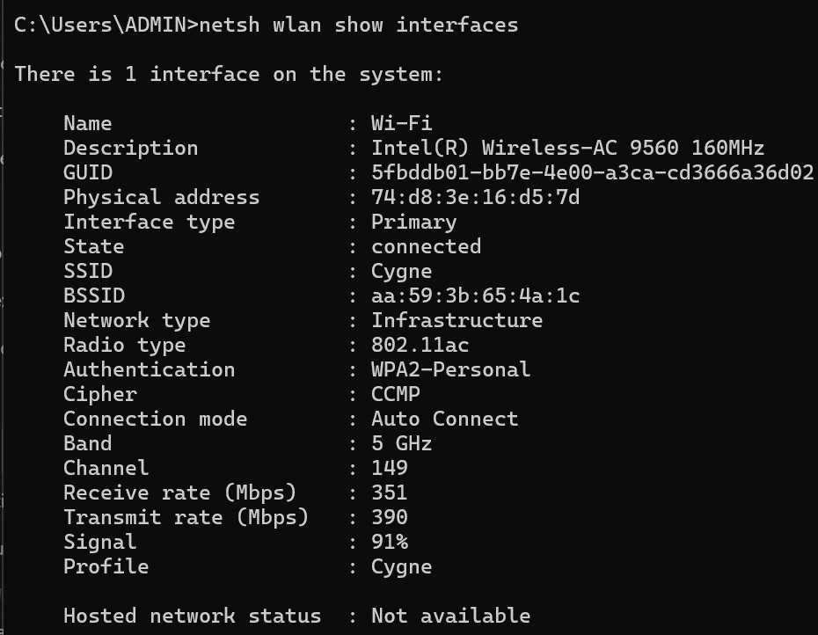
8.What is the difference between IEEE and WFA
• IEEE (Institute of Electrical and Electronics Engineers) is an IEEE that develops technical standards for networking.It creates Wi-Fi standards like 802.11 (a, b, n, ac, ax).
• WFA (Wi-Fi Alliance) is an Wi-Fi Alliance that tests and certifies devices based on those standards.It ensures that Wi-Fi devices work properly and are compatible with each other.
9.List down the type of Wi-Fi internet connectivity backhaul, share your home/college's wireless internet connectivity backhaul name and its properties
Backhaul means the connection between your Wi-Fi network and the main internet source (ISP).
Common types of backhaul are:
- Fiber (Optical Fiber) – Very high speed and reliable
- DSL (Telephone Line) – Uses phone lines, moderate speed
- Cable (Coaxial) – Used by cable TV providers
- Cellular (4G/5G Hotspot) – Internet from mobile network
- Wireless Point-to-Point – Used in campuses/buildings
In my case, I am using a mobile hotspot, so the backhaul is:
Cellular Network (4G/5G)
This means,my mobile phone receives internet from a cellular network.Then it shares it with my laptop via Wi-Fi
Properties:
- Type: Cellular (4G/5G)
- Speed: Depends on network signal (can vary)
- Latency: Medium
- Reliability: Depends on signal strength
- Mobility: High
10. List down the Wi-Fi topologies and use cases of each one.
Wi-Fi networks are organized in different structures called topologies based on how devices are connected.
1. Infrastructure Mode
In this topology, all devices connect through a Wi-Fi Access Point (router). Devices communicate through the access point instead of directly with each other.
Use Case:
Used in homes, offices, and colleges for regular internet access.
2. Ad-Hoc Mode (IBSS)
In this topology, devices connect directly with each other without using any access point. It is a peer-to-peer connection.
Use Case:
Used for file sharing between laptops or mobile devices without a router.

3. Repeater Mode
In this topology, a repeater receives the existing Wi-Fi signal and retransmits it to extend the coverage area. It helps in improving signal strength in weak areas.
Use Case:
Used in large homes, offices, or buildings where Wi-Fi signal is weak or needs to cover a larger area.

4. Bridge Mode
In this topology, a wireless bridge connects two separate networks or locations without using cables. It allows communication between different network segments.
Use Case:
Used to connect two buildings, campuses, or offices wirelessly where laying cables is difficult.
5. Mesh Topology
In this topology, multiple access points are interconnected, and each node can communicate with others. It provides high reliability.
Use Case:
Used in smart homes, large buildings, and IoT-based networks

